
ROBOT EMBEDDED PROGRAMING
Lab 6 Coordinate Frame Management Using tf

HUMBER POLYTECHNIC
FACULTY OF APPLIED SCIENCES AND TECHNOLOGY

Name:
Lance Quan
Michael McCorkell
Percy Sanford
Tyler Brannon

Objective
The objective of this lab is to introduce students to coordinate frame management in ROS 2 Jazzy using the tf2 system. Students will build a URDF model of a simple robot, publish its state through a Python node, and broadcast the robot’s transforms. The lab also emphasizes visualization, where students will use RViz2 to observe the robot geometry, motion, and transforms. Through this work, students gain hands-on experience with URDF modeling, tf transformations, and visualization tools in ROS 2.

Learning outcomes
By the end of this lab, students will be able to:
- Import an external robot 3D CAD geometry into ROS 2 and integrate it with a URDF model.
- Create a minimal URDF file to define the geometry and configuration of a robot.
- Develop a ROS 2 Jazzy package and launch file to load and visualize a CAD-based robot model.
- Publish robot states using a Python node and broadcast transforms through the tf2 system.
- Visualize robot geometry and transformations in RViz2, including coordinate frames and robot motion.
- Demonstrate understanding of the role of URDF, launch files, and tf in managing robot description and visualization within ROS 2.

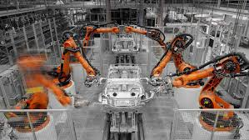
Source

Prerequisites

Source the ROS2 environment by typing this:

source /opt/ros/jazzy/setup.bash

printenv ROS_DISTRO
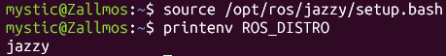
Make sure we we have all necessary ROS2 packages.

We need joint_state_publisher_gui which enables us to set the joint position and orientation and to publish the JointState message. This is a package that creates a Graphics User Interface (GUI) for setting and publishing joint state values for a given URDF. Then, we will need the robot_state_publisher package for the robot_state_publisher node. We will also need RVIz package. This package is used to visualize the geometry and motion of a robot by using a simple GUI.

source /opt/ros/jazzy/setup.bash

sudo apt install ros-jazzy-joint-state-publisher-gui
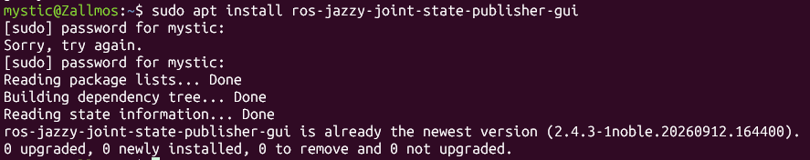
sudo apt install ros-jazzy-robot-state-publisher
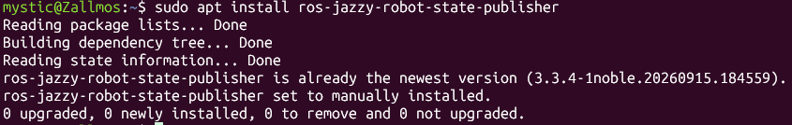
sudo apt install ros-jazzy-rviz2
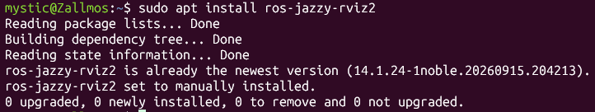
ros2 pkg list

ros2 pkg list | grep joint
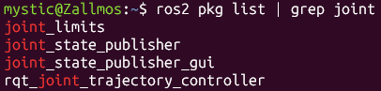
joint_state_publisher
joint_state_publisher_gui

ros2 pkg list | grep rviz
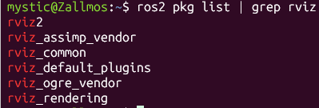
rviz2
rviz_assimp_vendor
rviz_common
rviz_default_plugins
rviz_ogre_vendor
rviz_rendering

Tip: If you would like to navigate to the main folder, open new file explorer on windows (if you are using WSL2) and type:
\\wsl$\Ubuntu-24.04\home\<your-username>

Instructions:

Create the Package
Open a terminal, source the ROS2 underlay, and create a workspace folder

source /opt/ros/jazzy/setup.bash

cd ~
mkdir -p lab6_ws/src
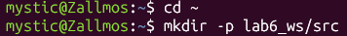
You have two options for creating a package: using a C++ build system or a Python build system. In this lab, we will use the C++ build system—not to write C++ code, but simply to generate the appropriate source file structure. To begin, navigate to the source folder:

cd ~/lab6_ws/src
Create an empty package

ros2 pkg create --build-type ament_cmake demo_robot
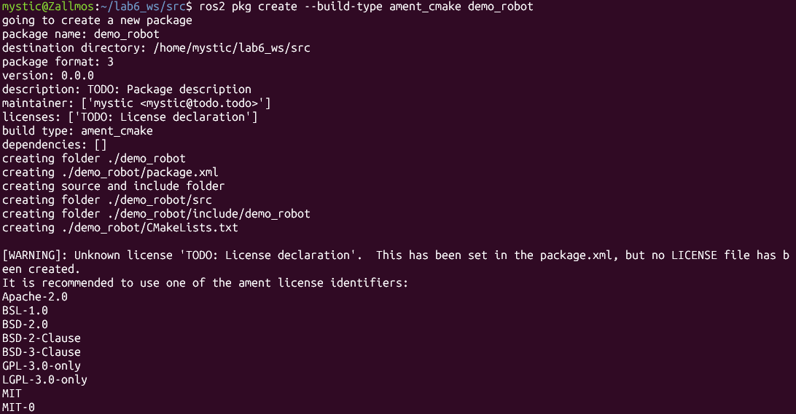
The package is named “demo_robot”, which generates the standard ROS 2 package file structure.

cd ~/lab6_ws
Next, open VS (code .) and navigate to the package’s base folder /lab6_ws/src/demo_robot

Next, let us create four folders (launch, urdf, config, mesh) inside of this folder. The folder “launch” will be used to store the Python launch file. The folder “urdf” will be used to store the “urdf” file of the model. The “config” folder will be used to store the RViz configuration file. The folder mesh will be used to store the CAD geometry.
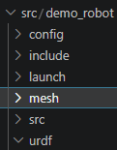

We usually export every part of the robot as a Collada (dae) file. Download the files provided on BB, navigate via file explorer to mesh folder, and save the downloaded files in the mesh folder. Save files as base_link.dae, first_link.dae, second_link.dae, and third_link.dae.

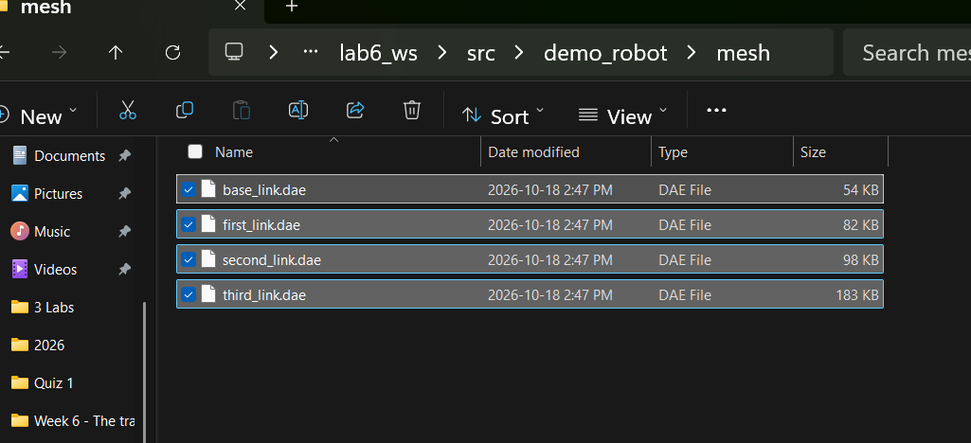
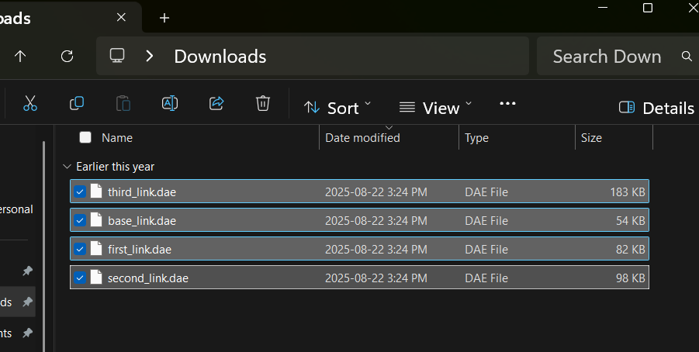

Back to VS, navigate to the “urdf” folder and create a URDF file. Call the urdf file “model.urdf”. Copy pastes the content of the model.urdf file provided (on BB)

The next step is to create a launch file. Navigate to the folder “launch” (the full path is “~/demo_ws/src/demo_robot/launch”). Inside of that folder create a file called “display.launch.py”. Copy pastes the content of the launch file provided (on BB)

Modify the package.xml and CMakeLists.txt Files
Before we can build the package, we need to modify two files: package.xml and CMakeLists.txt files. These two files are located in the base package folder “~/demo_ws/src/demo_robot”

Open the file called package.xml, and add these lines:

<exec_depend>joint_state_publisher_gui</exec_depend>
<exec_depend>robot_state_publisher</exec_depend>
<exec_depend>rviz2</exec_depend>

This will tell to the ROS2 build system that our package depends on these additional packages. The next step is to modify the CMake file of the complete project. Open the file called CMakeLists.txt and add the following lines:

install(
DIRECTORY launch urdf config mesh
DESTINATION share/${PROJECT_NAME}
)

before “if(BUILD_TESTING)”. These lines will ensure that the CMake system can locate the launch, urdf, and rviz configuration files.

Build the project

To build the project. Go to the base folder of the project:

cd ~/lab6_ws

Before we build the project, we need to make sure that all the dependencies are installed on the system. To do that, we use rosdep. To install rosdep, type this

sudo apt-get install python3-rosdep
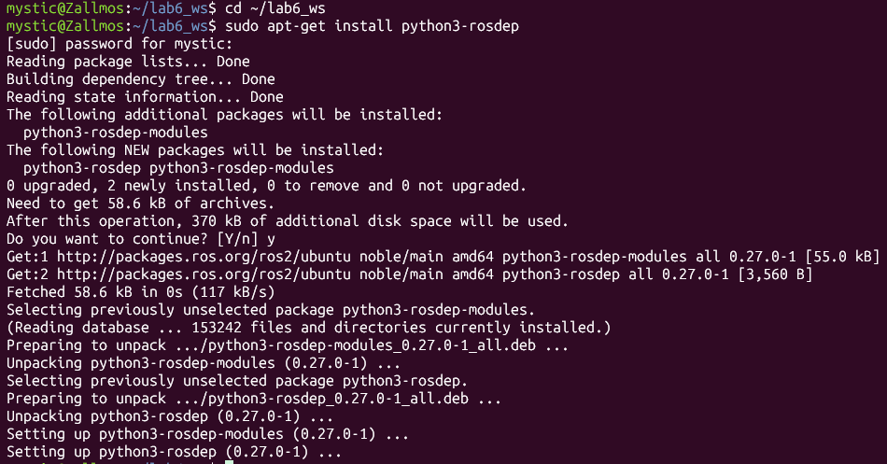
Then, type this

sudo rosdep init
rosdep update
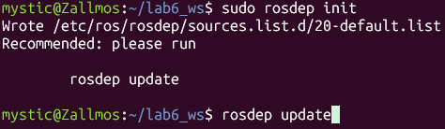
Verify that all ROS2 dependencies are installed by running this

rosdep install -i --from-path src --rosdistro jazzy -y
Finally, we can build everything by executing this command in the base workspace folder ~/lab6_ws/

colcon build --symlink-install --packages-select demo_robot

Next, let us start the launch file. To do that, open a new terminal, and create an overlay by sourcing the environment:

source ~/lab6_ws/install/setup.bash

Finally, run the launch file by typing this

ros2 launch demo_robot display.launch.py
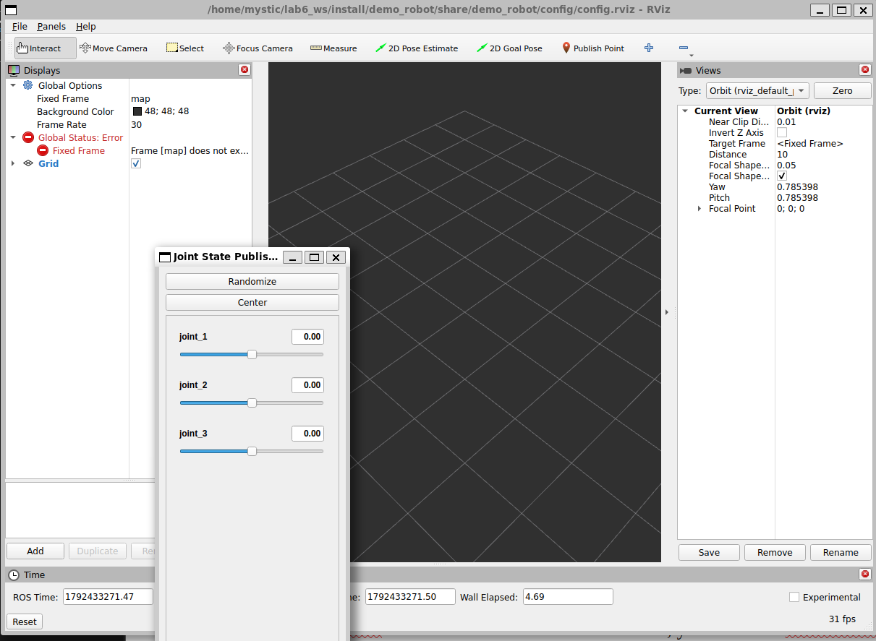
At first, nothing will appear in the RViz window. This happens because the parameters need to be adjusted manually for the model to display correctly. After making the adjustments, save the configuration to a file. The next time you open RViz, the saved parameters will load automatically, and no further manual adjustments will be needed.

Here is how to adjust the RViz parameters.
1.) Click on “Add” in Display menu, and click on “By display type” tab. Then, search for “RobotModel”. Select this and click on OK. Then, you will see “RobotModel” in “Displays” menu on the left. Expand the “RobotModel”. Find “Description Source”. From the drop-down menu next to “Description Source”, select “Topic”. Then, find under “RobotModel”, the option “Description Topic”, and from the drop-down menu select “/robot_description”. You will see that links of the robot will appear on the screen. However, they are not ordered. To order them, under “Global Options” (in “Displays” menu), find “Fixed Frame”, and from the drop-down menu select “base_link”. Now, you will observe that the complete robot model is properly displayed.
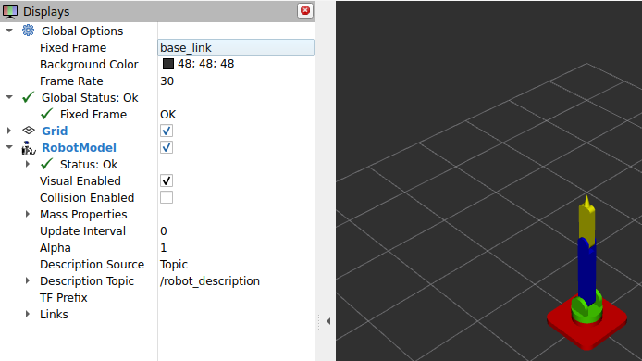
2.) Save the current configuration in the file. Click on “File”, “Save Config As”. The name of the file should be “config.rviz”. The file should be saved in the created config folder.

Test the saved parameters. Close RViz. Then, we need to rebuild the package. Open a new terminal and type

source /opt/ros/jazzy/setup.bash
cd ~/lab6_ws/
colcon build
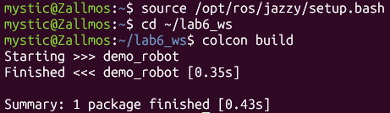
Then, open a new terminal
source /opt/ros/jazzy/setup.bash
source ~/lab6_ws/install/setup.bash
ros2 launch demo_robot display.launch.py
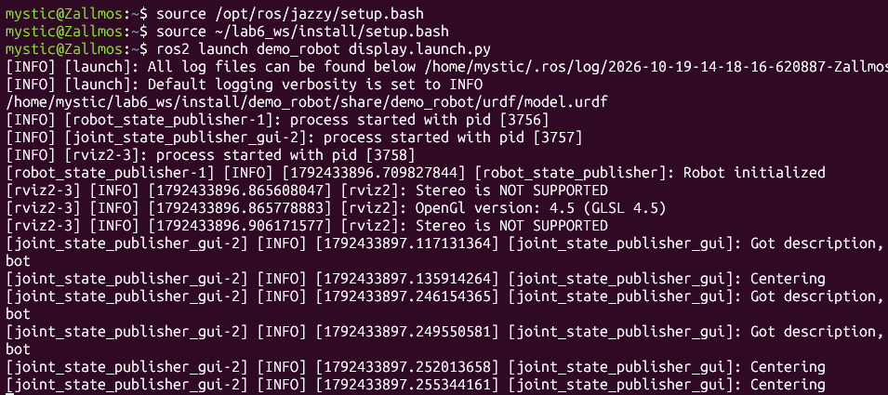
This will display everything.

Nodes and topics

This graph is displayed by running these commands in a new terminal (after building everything)

sudo apt update && sudo apt update
sudo apt install '~nros-jazzy-rqt*'
source /opt/ros/jazzy/setup.bash
rqt_graph
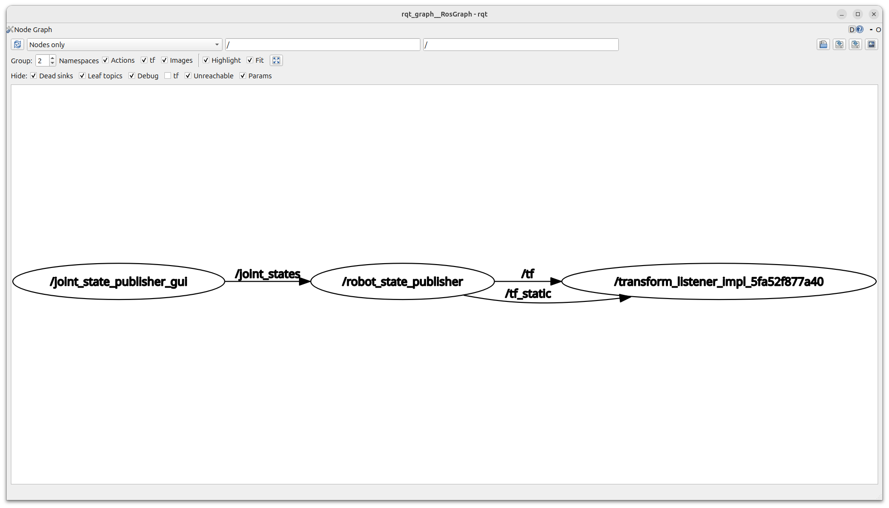
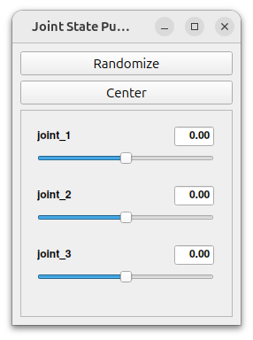
This graph shows the nodes and the communication topics between them. The first node is /joint_state_publisher_gui, which opens a graphical interface for adjusting the robot’s joint positions and orientations. This interface appears as the slider window used in the RViz simulation:

When the user sets the position and orientation of a joint, its state is published on the /joint_states topic.

In ROS 2, the state of a joint (whether revolute or prismatic) includes three components:
- Position
  - Revolute joints: angle of rotation, in radians (rad).
  - Prismatic joints: linear displacement, in meters (m).
- Velocity
  - Revolute joints: angular velocity, in radians per second (rad/s).
  - Prismatic joints: linear velocity, in meters per second (m/s).
- Effort
  - Revolute joints: applied torque, in Newton-meters (Nm).
  - Prismatic joints: applied force, in Newtons (N).

Note: This definition of “state” differs from the kinematic definition used in state-space models, where only positions and velocities are considered as states, and forces/torques are treated as inputs.

The joint state information is published and received through the /joint_states topic. To view details about this topic, run the following command (after sourcing your ROS 2 environment):

ros2 topic info /joint_states

The output should look somehow like this

Type: sensor_msgs/msg/JointState
Publisher count: 1
Subscription count: 1
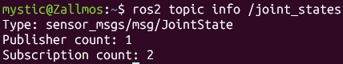
Here, the most important type is the type of message being sent, and this is sensor_msgs/msg/JointState. This is the message that contains the state. To verify this, type this

ros2 interface show sensor_msgs/msg/JointState
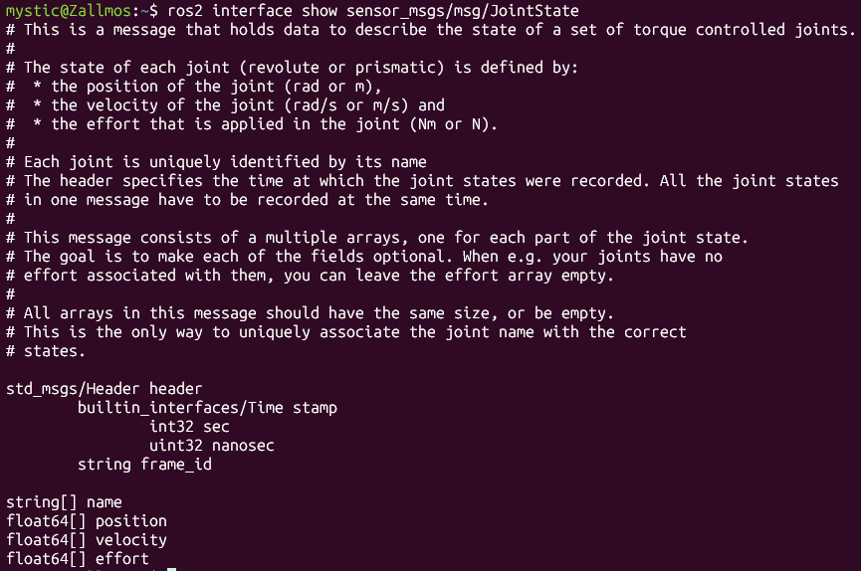
The output looks like this

# This is a message that holds data to describe the state of a set of torque controlled joints……
#........
# The state of
string[] name
float64[] position
float64[] velocity
float64[] effort

The /robot_state_publisher node receives joint state information and, using the robot’s URDF model, calculates the 3D poses of each link based on the robot’s kinematic tree. It relies on the robot_description parameter (URDF) and the joint positions from the /joint_states topic to perform forward kinematics. The resulting transformations are then published to the /tf topic.
The tf2 library manages these transformations, maintaining a tree of coordinate frames and allowing vectors, points, and other quantities to be transformed between frames over time.

The transformations published to /tf are then received by the /transform_listener node. This makes it possible to visualize the robot’s motion and coordinate frames in RViz. Although RViz runs as a node, it does not appear in the rqt_graph.

Deliverables
By the end of this lab, students must submit:
Short Report (1–2 pages)
1. TF Tree
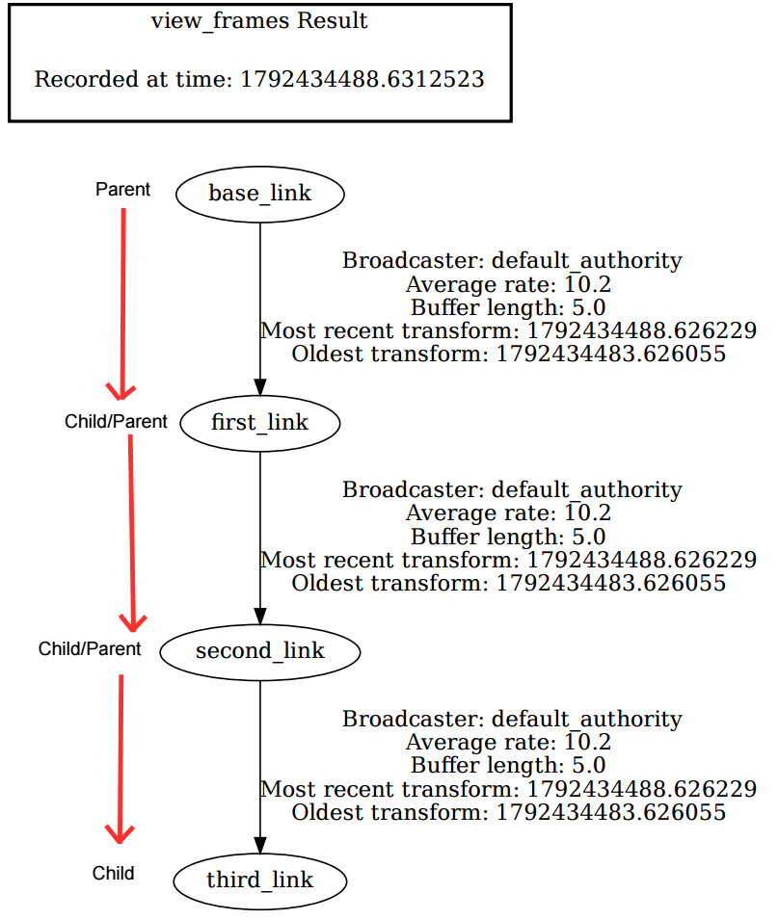

Joint 1:
parent link: base_link
child link: first_link

Joint 2:
parent link: first_link
child link: second_link

Joint 3:
parent link: second_link
child link: third_link

2. Short Answer Questions

1. Why does RViz show the links in the wrong place until the Fixed Frame is set to base_link?
RViz places the links incorrectly until the Fixed Frame is set to base_link because the Fixed Frame is the reference that every other frame’s position is calculated from. base_link is the root of the transform tree (the parent of the child links), so setting it as the Fixed Frame lets RViz compute each child’s pose relative to it. If you chose a different link as the Fixed Frame instead, that link would become the reference, and everything would be positioned relative to it.

2. What would happen to the TF tree if one joint were missing from the URDF?
The processed image showed a “No tf data received” message, meaning RViz wasn’t getting any transform data. Without it, RViz couldn’t build the TF tree, so it couldn’t position the links and the model was drawn incorrectly.

3. If /joint_state_publisher_gui is stopped, what happens to the transforms of the moving links? Why?
The model stays frozen in place until a transform is published for the link. For example, running ros2 run tf2_ros static_transform_publisher 0 0 0 1.57 0 0 base_link third_link publishes a fixed transform from base_link to third_link (a 1.57 rad yaw rotation, with no translation). RViz then has the TF data it needs to place the link.

